Business CareWare


How To Audit CABS AutoEmails
How To Document

Document Changes

Date | Version | Change Description | Changed By
01/12/2016 | 1.0 | Original Version | TT
20/02/2017 | 1.1 | Updated after implementation of table function utf_AutoEmailStatus to enable production of better AutoEmail diagnostic information | TT

Table of Contents
1 Introduction 3
2 View vw_AEFLINK 3
3 Table Function utf_AutoEmailStatus 3
4 Table AutoEmailFunction 5
5 AutoEmailFunction Audit Tables 5
6 SQL Server System Mail Tables 6
7 Combined Audit SQL Script 6

Introduction

This document provides a description of how to check what current status of the CABS AutoEmailer and how to obtain historical audit information. This is achieved by running SQL scripts and as such access to MS SQL Server Management Studio will be required.

Note: Autoemails will only ever be sent if:

- The SQL Scheduled Job “[CABS] Auto-Emailer Session Check” is running (which calls stored procedure “CABS_AUTO_EMAIL_FUNCS_SESS_CHECK” or

- The stored procedure “CABS_AUTO_EMAIL_FUNCS_SESS_CHECK” is run manually.

To stop CABS sending CABS Autoemails simply disable the above mentioned Scheduled SQL Job.

View vw_AEFLINK

Most emails are triggered by changes to records in a database table. This results in a record either being inserted or updated in table aef_link.

There is a view called vw_AEFLINK that stores the current state of the autoemail queue.

The SQL query:

SELECT * FROM vw_AEFLink WHERE AEFL_Sent = 0
AND SessionSendable = 1
AND Sendable = 1
AND MatchCriteria = 1
AND DATEDIFF (minute, GETDATE(), AEFL_SendTime) <=0

will return all autoemails that will be processed the next time stored procedure “CABS_AUTO_EMAIL_FUNCS_SESS_CHECK” is executed.

Just because records are returned by this query is no guarantee that an email will be sent.

Table Function utf_AutoEmailStatus

The table function utf_AutoEmailStatus returns the status of either all the autoemails in the queue or autoemails pertaining to any specific function.

This function provides better diagnostic information that simply a query run against vw_AEFLINK as described in the previous section. To get data on all autoemails run the query:

SELECT * FROM [dbo].utf_AutoEmailStatus('')

This will return data in the following format:

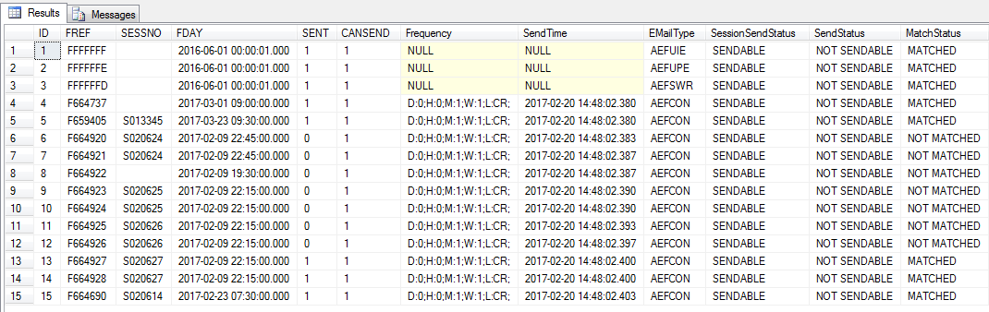
Figure 1 - AutoEmail Diagnostic Data - Part 1

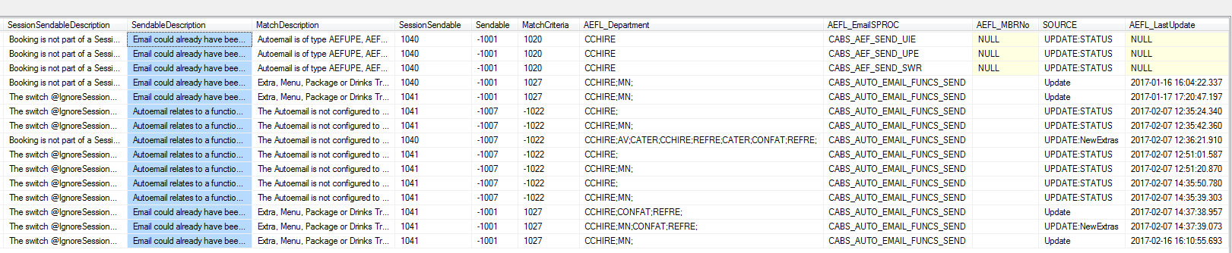
Figure 2 - AutoEmail Diagnostic Data - Part 2

The key columns here are SessionSendStatus, SendStatus and MatchStatus, Sent and CanSend (Figure 1).

If SessionData and SendStatus are both set to ‘SENDABLE’ and MatchStatus set to ‘MATCHED’, CANSEND is 1 and SENT is 0 then the AutoEMail should be sendable.

Status description fields are available to provide more detailed information to aid in the understanding of the Status fields (SessionSendableDescription, SendableDescription, MatchDescription).

To get data on all autoemails for a given function reference use the query:

SELECT * FROM [dbo].utf_AutoEmailStatus('FXXXXXX')

where FXXXXXX is the function reference required.

Table AutoEmailFunction

Table AutoEmailFunction is used by the code to store transitory data. It should not contain any data because records are deleted from this table once an email has been processed.

Therefore the query:

SELECT * FROM AutoEmailFunction

should not return any data. If it does, it could be indicative of an issue and may impact future emails.

AutoEmailFunction Audit Tables

Currently there are 2 CABS AutoEmail audit tables:

- AutoEmailFunction_SEND_PARAMS and

- AutoEmailFunction_FromTrigger

Table AutoEmailFunction_SEND_PARAMS contains data associated with the sending of an email e.g. running SQL:

SELECT * FROM AutoEmailFunction_SEND_PARAMS

Results in:

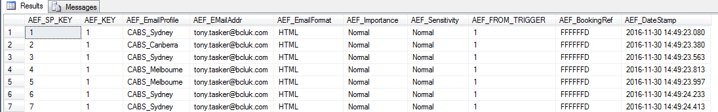
Figure 3 - Example Data from AutoEmail_SEND_PARAMS

Table AutoEmailFunction_FromTrigger contains CABS related data pertinent to the autoemail that has been processed.

SELECT * FROM AutoEmailFunction_FromTrigger

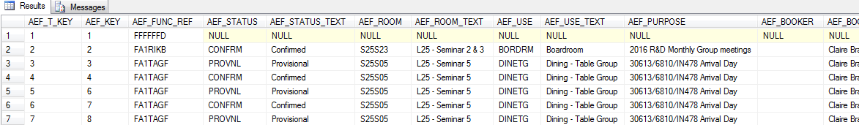
Figure 4 - Example Data from AutoEmail_FromTrigger

The two tables are linked by column AEF_KEY.

SQL Server System Mail Tables

CABS AutoEmailer uses SQL emailing services. Essentially, CABS Autoemailer adds emails to the SQL Mail queue and SQL Server processes the emails. A number of system tables are available in the “msdb” database to provide audit information.

The following SQL could be used to provide audit information:

USE MSDB
SELECT * FROM sysmail_allitems

USE MSDB
SELECT * FROM sysmail_sentitems

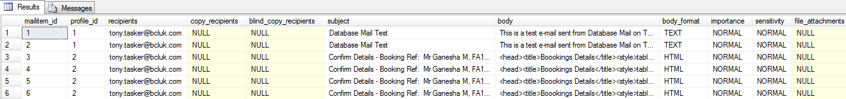
Figure 5 - Example Data from Sysmail_SentItems

USE MSDB
SELECT * FROM sysmail_unsentitems

USE MSDB
SELECT * FROM sysmail_faileditems

Combined Audit SQL Script

When an email is submitted to the SQL email queue, mailitem_id is returned and subsequently added to table AutoEmailFunction_FromTrigger. This means that it is possible to run a single query to extract and combine audit information from all tables.

The following SQL query returns consolidated information:

SELECT m.mailitem_id
, aefr.AEF_KEY
, m.recipients
, m.copy_recipients
, m.blind_copy_recipients
, m.body_format
, m.subject
, m.sent_date
, m.sent_status
, m.body
, AEF_EmailProfile
, aesp.AEF_EMailAddr
, aesp.AEF_BookingRef
, aefr.AEF_ROUTE
, SUBSTRING(aefr.AEF_ROUTE, CHARINDEX('-', aefr.AEF_ROUTE)+1, 6) AS Template
, aefr.AEF_SENT
, aefr.AEF_SENT_DATE
FROM [dbo].[AutoEmailFunction_FromTrigger] AS aefr
INNER JOIN [dbo].[AutoEmailFunction_SEND_PARAMS] AS aesp ON aefr.AEF_KEY = aesp.AEF_KEY
INNER JOIN [msdb].[dbo].[sysmail_allitems] AS m ON m.mailitem_id = aefr.AEF_MAILITEM_ID
ORDER BY aefr.AEF_SENT_DATE DESC

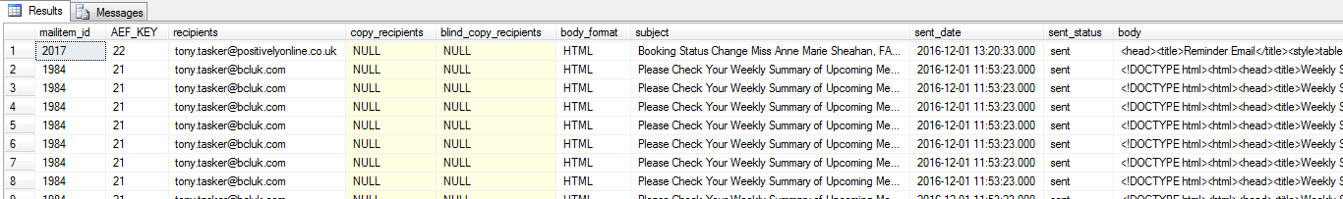
Figure 6 - Example Data from Consolidated SQL Script

